Appendix A
Real Pilot Reasoning Process

Mahery ANDRIAMBOLOLONA,
Pascal LEFEUVRE,

Version 1.0
11/03/03

1 Introduction 4
1.1 Context 4
1.2 Overview 4
2 Description of the maneuvers 4
2.1 Principles of Basic Fighter Maneuvers 4
2.2 Maneuvers 6
3 Real pilot reasoning process 9
3.1 Overview 9
3.2 Vocabulary 10
3.2.1 Positional geometry 10
3.2.2 Weapon envelope 13
3.2.3 Pilot Experience - Energy and position principles 13
3.3 Offensive approach 14
3.3.1 Steps to shoot an enemy 14
3.3.2 State machine 16
4 Pilot model 16
4.1 Pilot Model inputs 17
4.2 Interpreting data 19
4.2.1 Position satisfaction rate 20
4.2.2 Energy difference rate 21
4.2.3 Risk rate 22
4.2.4 Reliability rate 22
4.3 Outputs 23
4.4 Missing skills 24
4.4.1 Maneuver Initial conditions 24
4.4.2 Maneuver Technical information 24
4.4.3 Assessing a maneuver destination location 24
5 Conclusion 26
6 GLOSSARY 27
7 Bibliography 28
8 Links 28

Introduction

Context

This appendix stands directly as part of the “Choose Maneuver Report”.

Overview

This document aims to present what information has been collected about the real pilot making decision process.

It starts giving an overview of dogfight context: the first chapter provides a quick description of some common maneuvers used. The second chapter presents the principles used by a real pilot to choose the most accurate maneuver.

Description of the maneuvers

Principles of Basic Fighter Maneuvers

This section deals with principles of Basic Fight Maneuvers. There are presented out of any tactical context. Besides, fight maneuvers are designed for tactical purposes. They are the topic of the next section.

- Roll
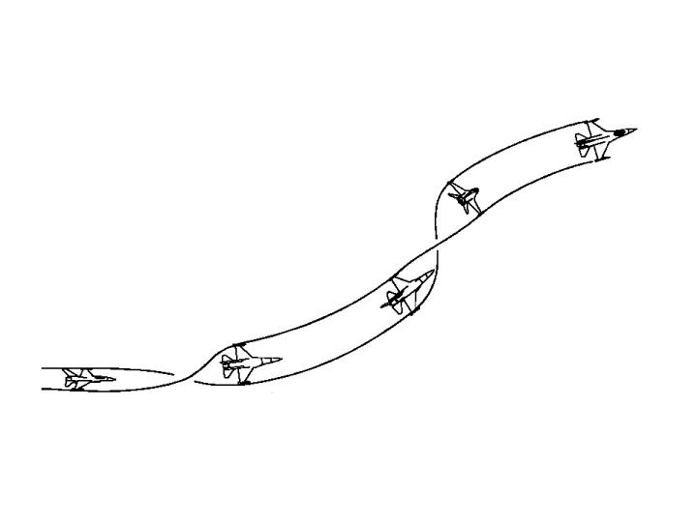Figure 1: roll

Roll is a basic aircraft movement. It consists in rotating along the longitudinal axis. That is this line that extends along the fuselage from nose to tail. As Rolling allows the pilot to position his lift vector, it enables to slow the forward velocity of the aircraft -The lift vector is a vector that sticks directly out of the top of the jet, perpendicular to the aircraft's wings.

- Turn

It is one of the bases of aircraft maneuvers. Some features are crucial when a pilot performs a turn: he must take the corner velocity into account. The corner velocity is a range of 330-340 KCAS airspeed at which the maximum allowable aircraft G and minimum turning radius can be generated. In a few words, it is a range at which the aircraft turn performance is the highest.

- Acceleration

When you pilot your aircraft, accelerating is a basis. The purpose is to increase distance from an object. The aircraft attitude determines the effect of gravity on acceleration. If the aircraft velocity vector is above the horizon, acceleration effectiveness is reduced. If velocity vector is below the horizon effectiveness is enhanced. Moreover, the fastest airspeed gain occurs when you are to 0 G. The speed you go influences your acceleration rate. It is the best in the speed range from 300 to 400 KCAS. The altitude at which you fly impacts the acceleration. The higher the aircraft flies the more effective the acceleration is because of increased thrust.

Maneuvers

- Barrel roll
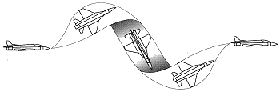
Figure 2: barrel roll

The maneuver name comes from the flight path the aircraft performs as the aircraft rolls round a central axis. It is a speed-consuming maneuver. When a barrel roll is initiated, the aircraft starts performing a spiral. Therefore it increases the through air distance between the aircraft and the point to be reached. Because of the speed loss, it takes more time to go from one point to another one.
- Offensively it is used to prevent overshooting (because of speed loss)
- Defensively, it is used to cause overshooting (because of speed loss)

- Lead Turn
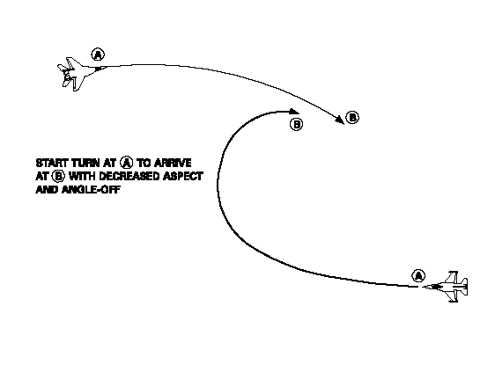
Figure 3: lead turn
Two aircraft are facing. The lead turn aims at positioning the attacker in the opponent six hours. In a few words, the attacker initiates a turn before passing the 3/9 line so that it can reduce the angle between its fuselage axis and the opponent’s nose axis. It can be performed in any plane.

- Split-S

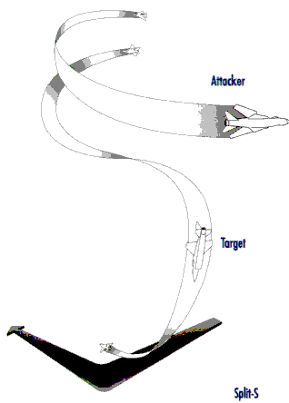
Figure 4: split S
The Split-S is a diving half-loop. Therefore, it is used to increase speed or bleed off altitude. It is a high altitude maneuver (be careful of your height). The Split-S is useful when you want to disengage a threat. Offensively, it is used to proceed a vertical lead turn (high to low).

- Immelman
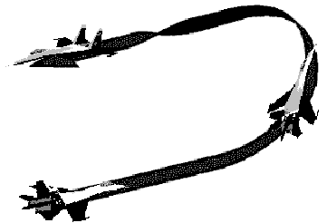
Figure 5: Immelmann
Immelman is neither an offensive nor a defensive maneuver. It looks like a half loop. It exchanges speed for altitude and reverses direction. Offensively, it can be used to proceed a vertical lead turn (low to high).

- Break Turn
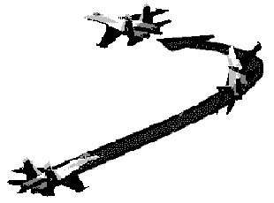
Figure 6: Break turn
The break turn results in a tight turn with high roll angle. It is a defensive maneuver used to avoid a missile or to deny the bandit weapon employment opportunity when he stands in your six. The point is to create as much angle as you can on the bandit. The break turn is high energy consuming.

Real pilot reasoning process

The point of this chapter is to provide some key information about the way a fighter pilot decides which maneuver he has to perform in a dogfight. These clues have been taken from a real F16 handbook downloaded from the Internet. In this document [1], the pilot reasoning process has been analyzed. This analysis will be discussed from the following perspective: trying to extract some good rules of thumb about when to perform such a maneuver in order to automate such a making decision process. Some ideas about the process automation will be the topic of the chapter 3.

Overview

A combat maneuver consists of positioning your aircraft in order that the enemy is in your weapon parameters. But it is also vital to keep your enemy from employing his ordnance against you. Maneuvering your aircraft is the ultimate step of an iterative and complex process of reassessment: observing, predicting, and maneuvering. The final step is a kill or disengagement.
To execute theses tasks, a pilot is required to keep in mind some crucial information:
- Both aircraft characteristics
- Enemy maneuvers
- Energy state of both aircraft
- Its weapons range
- Pilot proficiency
- Both aircraft positions
- Maneuver risks

These parameters can be easily classified:
- Positional geometry (both aircraft position, angles, range)
- Weapons envelope (weapons range, angle required to shoot)
- Pilot Experience (Pilot proficiency, Both aircraft abilities, abilities to assess the enemy’s maneuvers, maneuver risks)

These notions must be defined before dealing with the attacker approach.

Vocabulary

Positional geometry

When speaking about an aircraft’s position relative to another, a pilot deals with range, aspect angle and angle-off. A pilot uses these parameters to evaluate whether he has a position advantage.

Range is the distance between two aircraft.

Aspect angle describes the relative position of the attacker to the target, without regard to the attacker's heading. It is defined as the angle measured from the tail of the target to the position of the attacker.

Angle-off is primarily concerned with the relative headings of two aircraft. Angle-off is defined as the angular distance between the longitudinal axes of the attacker and the defender. Whenever the attacker is pointing at the defender, the aspect angle and angle-off will be the same.
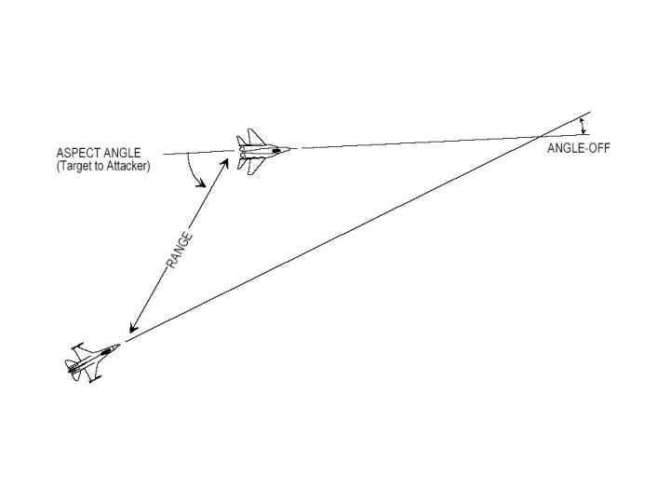
Figure 7: position geometry

Generally speaking, it can be assumed that the closer you are from your target the better your chances are to shoot it down. The less angle problems there are (small aspect and angle off), the closer the attacker is to the ideal shooting position.

All the previous concepts can be merged to give more tactical oriented notion. A pilot visualizes the two aircraft separation in terms of turning room. Turning room is the offset or distance from the bandit. Turning can be acquired in either the lateral or vertical planes or a combination of both. In order to understand the concept of turning room, turning circle should be introduced.

Turning Circle is a concept involved in the approach maneuvers executed by an attacker. Turn circle is simply the defender’s path that an attacker cuts through the sky when the defender turns. The first goal of an attacker is to enter into its opponent’s turning circle. Once in the defender’s turn circle, the attacker can initiate a direct pursuit to position into its opponent’s vulnerable cone.

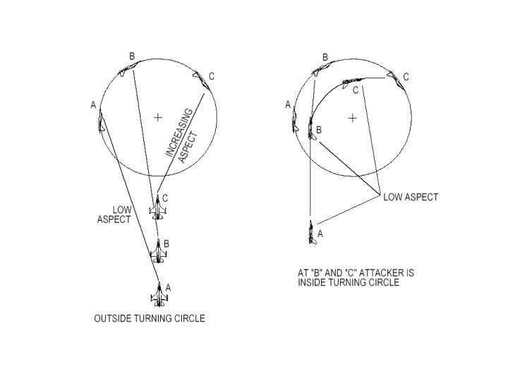
Figure 8: turning circle

When tracking an opponent, an attacker aircraft’s nose position can be three different ways: its nose can point in front of the defender, closure rate increases, it is called lead pursuit. Behind the defender, closure rate decreases: it is lag pursuit. In both cases, angle-off increases. If it points at the adversary it is pure pursuit.

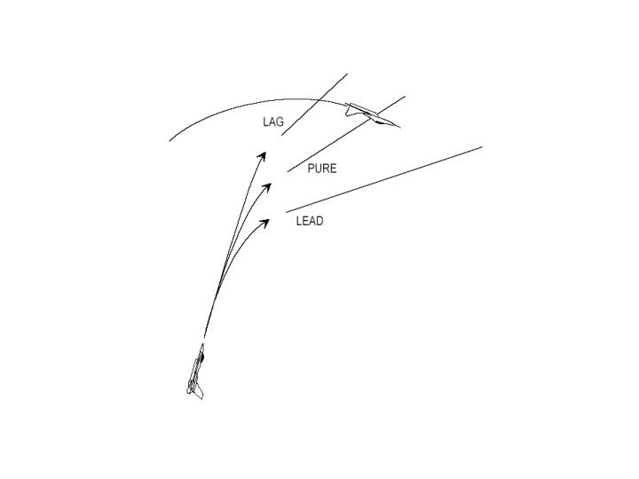
Figure 9: attack pursuit courses

According to angles and range, a pilot elaborates its sequence of maneuvers. Reassessing the turning room he modifies it. The way the pilot takes these parameters into account is the point of section “Offensive approach”. Besides as the Artificial Dogfight player is required to be as close as possible from a real dogfight pilot, the pilot model will also use these criteria in order to choose a maneuver.

Weapon envelope

The weapon envelope is the area around the bandit where your missiles or gun can be effective. These weapon requirements impose a maximum range, aspect and angle-off and pursuit course. That defines the notion of vulnerable cone of the opponent.

The gun weapon envelope is a circle around the bandit depicting the gun's maximum range. There is no minimum range circle.

Pilot Experience - Energy and position principles

The pilot game plan is established by following a principle acquired through practice: the constant balance between energy and position advantage.

Energy is composed of kinetic energy (speed) and potential energy (altitude). Maneuvering consumes energy. When you have more energy than your opponent you have a serious energy advantage on him. When you are maneuvering, you consume energy and there is a constant trade off between speed and altitude.

Besides, the ultimate purpose of an attacker pilot is to position his aircraft in weapon parameters. When you are in your opponent’s six hours, you definitely have a positional advantage. A good pilot should ask this question. How much energy or future maneuvering potential can be expended for a given positional advantage? That is why a pilot must constantly balance energy and position.

As solution, fight maneuvers have been designed to achieve weapon parameters within the minimum energy expenditure in the minimum time as possible.

Offensive approach

In this part it will be shown how the pilot’s behavior during dogfight (especially with guns) can be logically analyzed and organized for later use.

Steps to shoot an enemy

Here follows the state description in which it is liable to be when trying to gun an enemy.
- Outside the Turn Circle: entering it
One of the main issues when dog fighting is entering the opponent’s turn circle (TC). Actually, as long as you stay outside his TC, the aspect angle will increase and you will not be able to use ordnance.
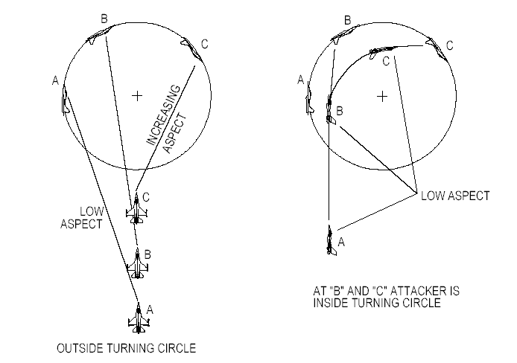
Figure 10: entering turn circle
- Inside the Turn Circle
The goal is now to solve the problem that has been created while transitioning TC: angles, range, speed etc. That is to say to place the aircraft in a position where ordnance can be employed. The maneuvers to be executed depend on what the bandit is doing (type of defense, maneuvers…). Mainly, there are two types of defense:
- Check & extend: the enemy ends his turn and accelerates to increase range and his energy. Consequently the attacker may find himself outside the TC. Thus he should again enter the TC.
- Continuous turn: the enemy wants to create angle problems, and bleed down the attacker’s energy.

- Closing for guns
That represents a state when all is made to place the aircraft in gun position. Closing for guns means also small range and speed. Two main strategies are provided when trying to get in firing position:
- Pull lead: try to maintain a lead pursuit and gun the enemy.
- Bid to lag: it consists in depleting enemy’s energy before gunning him. The principle resides in floating back to the enemy’s elbow while he is losing energy. The easiest way to proceed is to ease off of your turn to follow the enemy with a lag.

State machine
The different phases that have just been presented can be incorporated in a state machine that stands for pilot states. To each state corresponds a goal. For instance, when the pilot is “Outside the Turn Circle”, his goal is to “get inside the Turn Circle”. Considering this goal, information about the pilot, his aircraft and the enemy, and depending on the maneuvers he can proceed, he takes a decision to attempt this goal. The information taken into account will be discussed in the chapter 3. The following picture illustrates this state machine, only considering the pilot as an attacker that wants to gun the enemy.
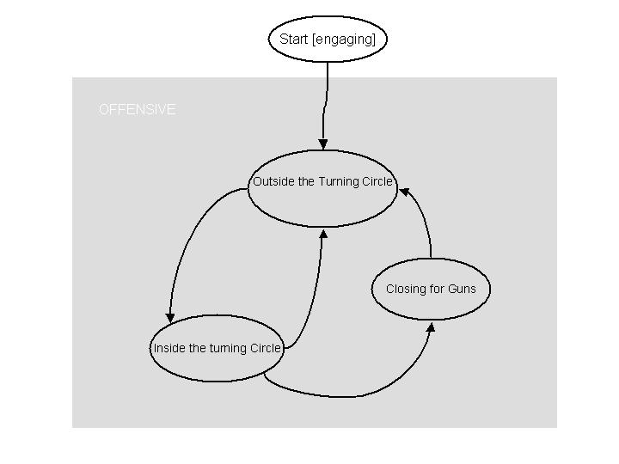
Figure 11: state machine

